Spindrift Day Sailer One
$3500.00 OBO
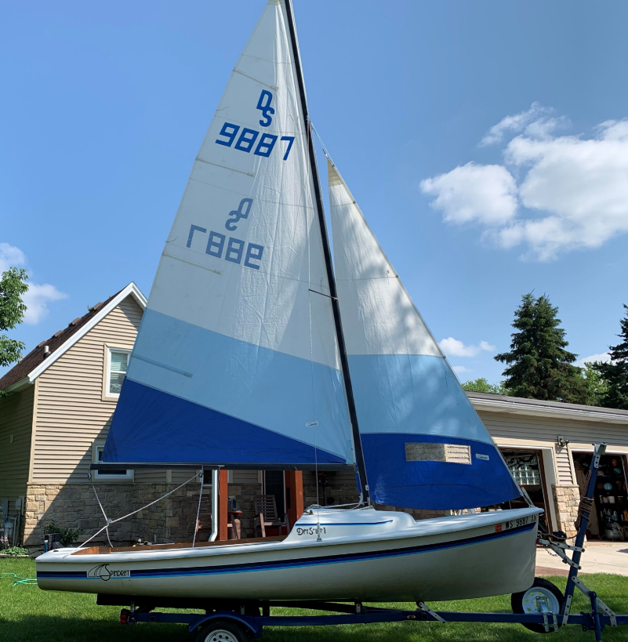
This boat has been great for a family sail or speeding across the water alone. Huge, deep, comfortable and secure cockpit, sheltered cozy cuddy cabin and well balanced responsive sailing performance. This is a boat that has appeal to both the novice family sailor as well as the experienced yachtsman. Plenty of storage, an easy-to-step hinged mast, pivoting rudder and centerboard. I bought a smaller sailboat so it is time to let this one go!

Manufacturer: Rebel Industries - 1983
Official length 16’ 9”
Total weight approx. 575 lbs.
Custom quality sails- blue sail color package in pristine condition
All new running rigging
ISO/NPG Gelcoat finish
Teak trim (all refinished)
Sit in cockpit with drain, Cuddy Cabin with built in storage shelves
Safety non skid surface
Centerboard with locking pawl
Mast support with roller for transporting
New motor mount

EZ-Load trailer – sandblasted, reinforced, repainted, rewired with new lights, new tires and spare, bearing buddies, new Greenfield sky winch and new rollers

Contact Lane Venden, lanevenden9021@gmail.com 608-574-9021.

